PM Trend

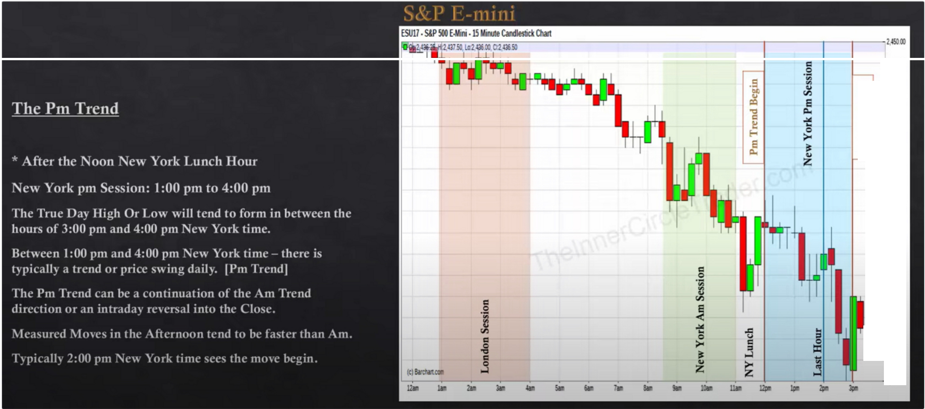

**-2,4£9.(1)**

"

'

**-2,-Ua«I**

"'

C

..

"'

**-2,4'1A>**

C

f-

**-2,4160:,**

E

**-2,"5.G:I**

**·2.""-«I**

**-2,.uam**

**-2,"'2.0:,**

**-2,,11..co**

**-2,.uom**

**-2,a,m**

**-2, 0,**

•

I

**-2,.mm**

I **-2,UIIXI**

**-2'350)**

-

tU<II)

Lunch is generally 12am to 1pm but it can start as early as 11am to as late as 2pm depends on the current market enviroment, but generally if the AM session is a fast market they are going to want to work trough lunch so a short lunch period of consolidation or a little retracement

When the morning sessions was *very* lethargic *very* slow, then the full lunch hour or even from 11am to 2 pm can be seen, that wont happen a lot. But generally we want to see some measure of consolidation or retracement around the noon to 1pm

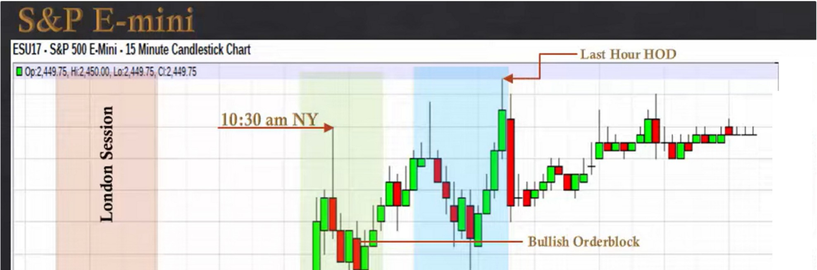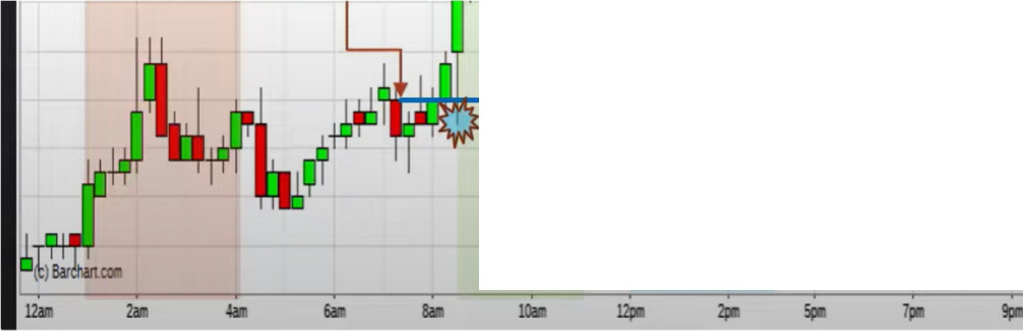

**2,452.00**

**-2,45100**

--

**-2,449.00**

- **2,448.00**

**-2,447.00**

**-2,446.00**

**-2,445.00**

- **2,444.00**

- **2,443.00**

**-2,442.00**

**Bullish Orderblock**

.**0**.**C**..**l**

**-2,44100**

"'

- **2,440.00**

**(;I)**

**-2,439.00**

**-2,43800**

**-2,437.00**

**-2,43600**

**2,43500**

**1Jjll**

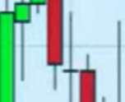

2,362.00

2,360.00

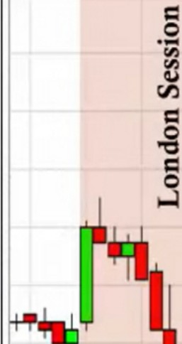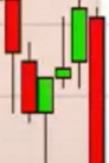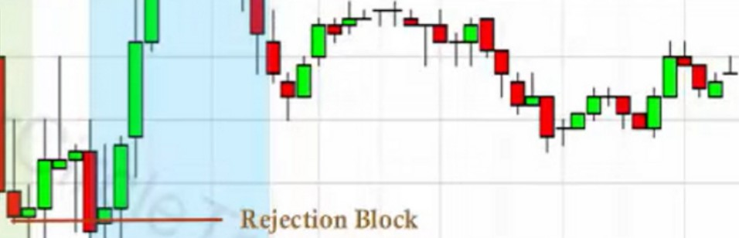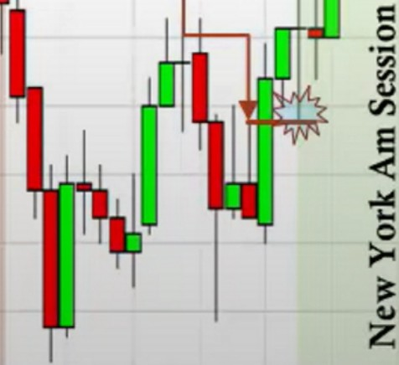

2,36.00

2,374.00

2,Jn.00

2,370.00

2,368.00

2,366.00

ESM17 • S&P 500E-M,ini 15 Minute Candlestick Chart

,36l.OO,Lol,363.50,Q:2.363.50



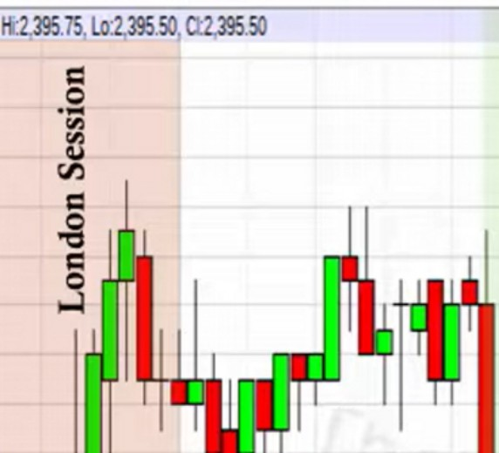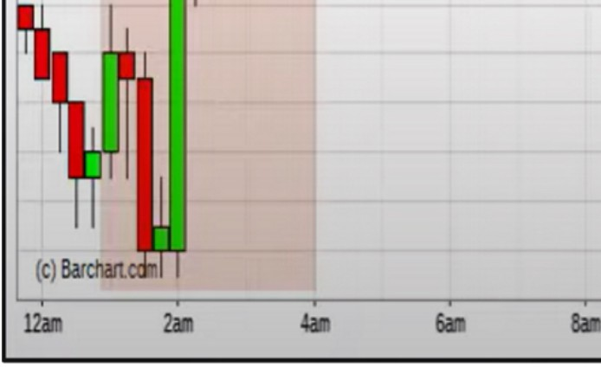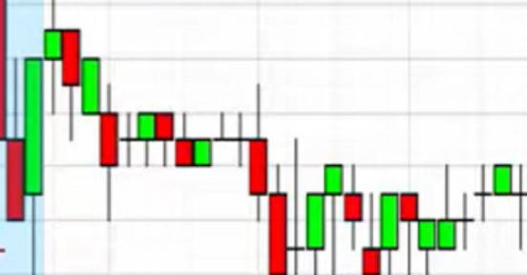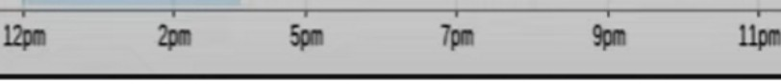

ESM17 •S&P 500E-Mini,15 Minute Candlestick Chart

* Op:2,395.75,

ReJection BJock

+OB

\11

+OB

·0-

=

"'

**tr.)**

2,399.50

2,399.00

2,398.50

2,398.00

2,397.50

2,397.00

2,396.50

2,396.00

Im

2,395.00

2,394.50

2,394.00

2,393.50

2,393.00

2,392.50

2,392.00

2,39LSO

2,39LOO

2,mso 2,m.00

2,389.50

2,389.00

2,388.50

2,38800

**10.**

(c)Barchan.wr '-,

12n 2n

Bullish Orderblock

2,358.00

2,356.00

2,354.00

2,352.00

2,350.00

2,348.00

2.346.00

2.34400

In this case the PM session cause a reversal, maybe because it came into a premium array?

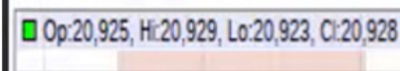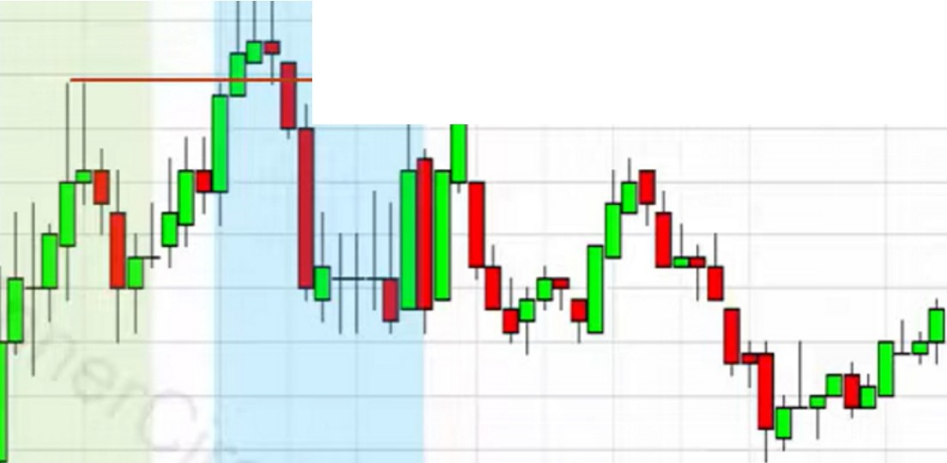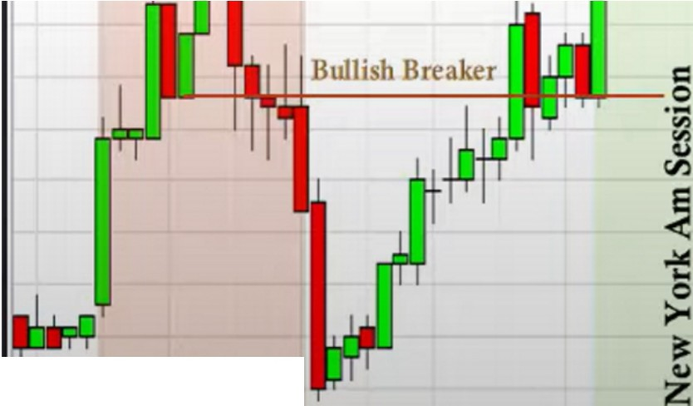

YMM17.Dow lndu30E-Min-i15Minute Candlestick Chart

Turtle Soup

120,965

-20,960

20,955

-20,950

20.

-20,925

-2092()

-

20,940

20,935

J20:915 20,910

-20,905

20,900

-20,895

-20,890

20,885

r88)

-20,875

20.870

Sell Stops

(C)Balchartccr

l.2'all **2a**'**ln**

**4a**' **ll**

**61**' **1**

**S**'**all**

**121a**

**Sp**' **a**

**9pa**

.

-20.865

ll'jn

120860

NQM17 •Nasdaq 100 E-Min-i15Minute Candlestick Chart

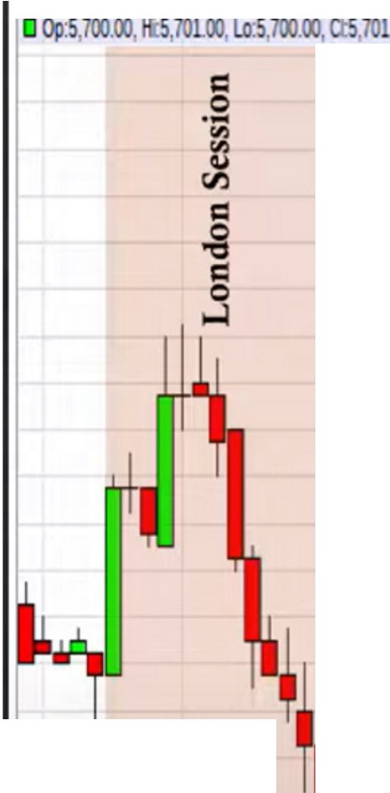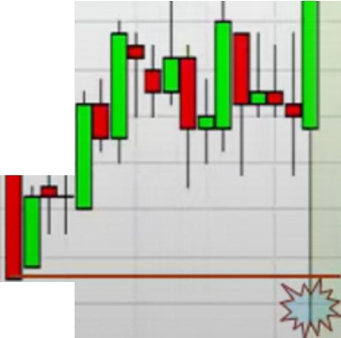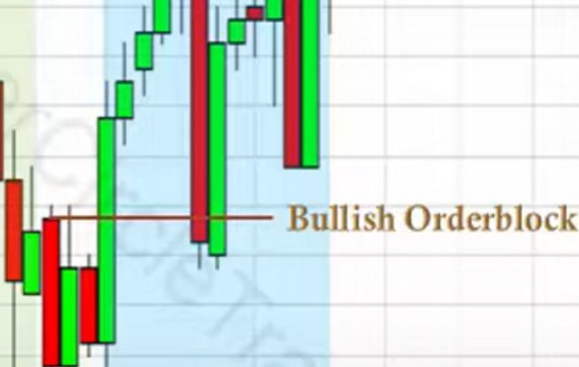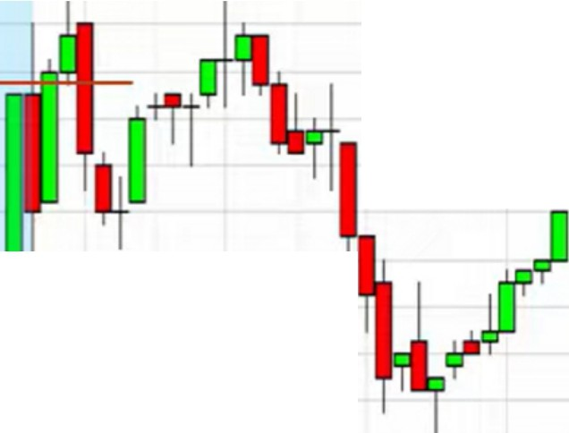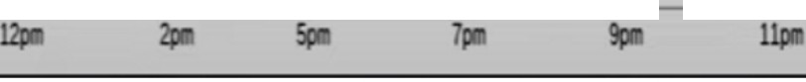

00 .5,101.oo

5,7 .00

5,705.00

lltjcclion lllolk

(c) **Bardlartton'**

*......,_----,---,-----.----.-----..----..----..----.-----.-----.--*

5,704.00

5,703.00

-

5,702.00

5,700.00

5,699.00

5,698.00

5,697.00

5,696.00

5,695.00

5,6!14.00

5,693.00

5,692.00

5,69LOO

5,69000

5,689.00

5,688.00

5,687.00

5,686.00

5,68500

5,68400

5,68300

--..-- 5,682.00

**12n**

**2.n 4all 6am**

**8aa 10.**

Index SMT

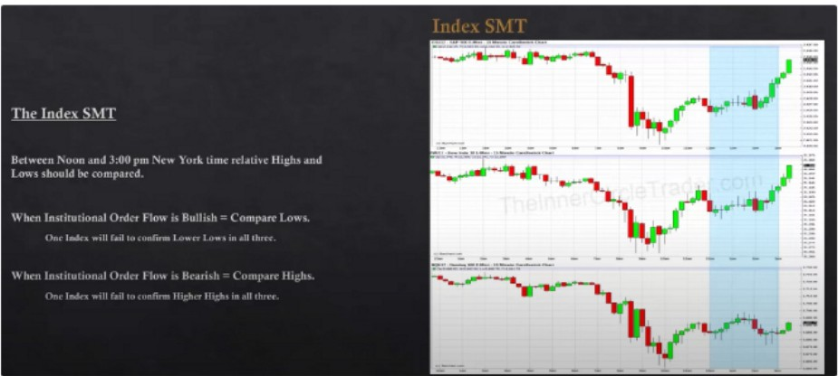

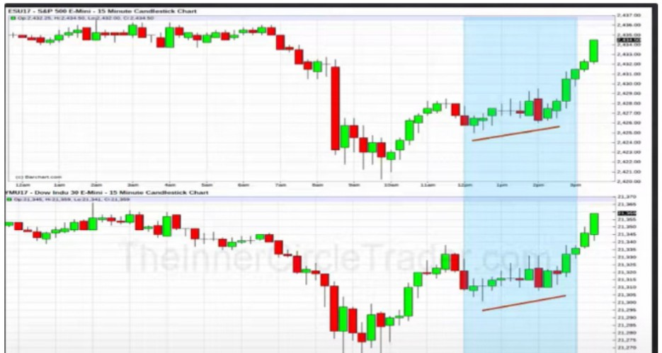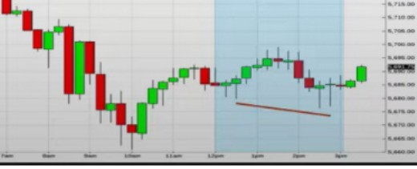

--.. ........_- -- --

-··--·- "---

If ICT sees this crack, his trade will be taken in the SP500, he primarily focuses on SP The drop down in the AM session couldve been a drop down into a discount array

The opening range will generally create the low/high of the day and the last hour will create the opposite end high/low of the day

So if we see a low form in the Am sessions and its been a really strong up day and during lunch weve seen no retracement and the PM session starts to indicate it wants to go higher to we can feel confident that any trade we make in the direction of the Am session will continue going into that last hour of the trading, 3pm the bond market close

If a day is bullish and the market rallies all AM session, then the PM session will seek sellside under AM session lows and reprice to any BISI (Buyside imbalance sellside inefficiency) once it is there expect a return to premium inside the range.

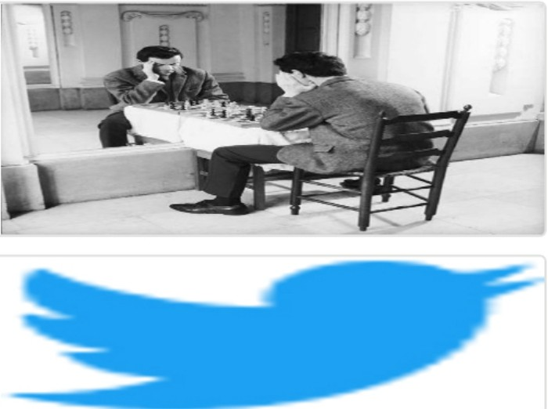Arjo I Twitter, lnstagram I Linktree

Linktree. Make your link do more. https://t.co/HhmmTN1fUI

JavaScript is not available.

"# https://twitter.com/arjoio